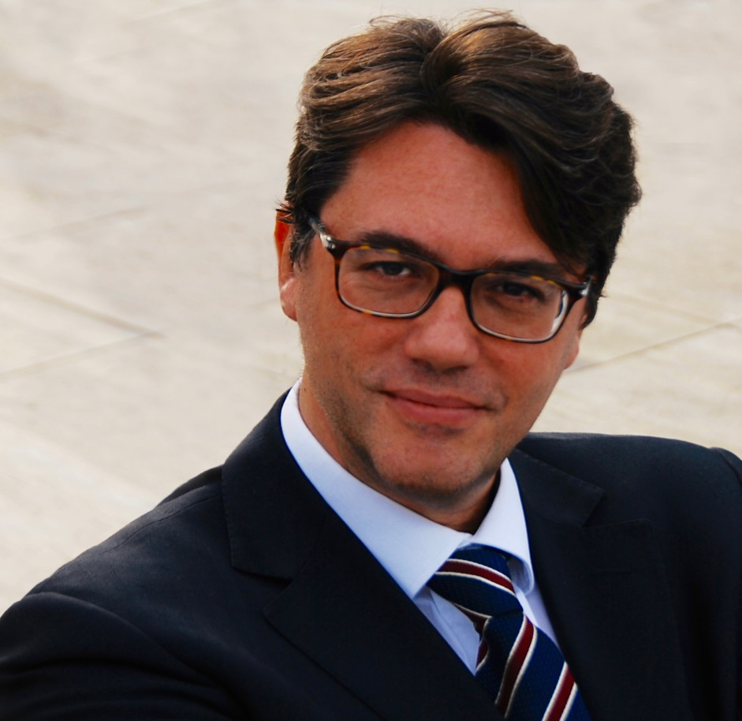

[Antonio Nicita](https://www.agcom.it/antonio-nicita)  is Commissioner of the Italian Regulatory Authority AGCOM and Professor of

Economic Policy at the Department of Economics and Law at Sapienza University of Rome,

has been Associate Professor of Economic Policy at the University of Siena, he was Visiting

Fulbright Professor at Yale University. In 2005-06 he was a Non Governmental Adviser of

International Competition Network (ICN) for the report on telecommunications sector. He is

on the Board of Directors of the Italian Society of Law and Economics, European Association

of Law and Economics and of the International Society for New Istitutional Economics

(ISNIE). In 2006-07 he was an economic adviser to the Italian Minister of Communications

and member of the Governamental Unit for the Improvement of Regulation. He was

Economic Adviser for the 2009 OECD Regulatory Report on Italy. He holds a Ph.D in Economics

form the University of Siena, Italy. His research interests cover Industrial organization,

Law and Economics, Competition Economics and Regulation. He is author of numerous publications.

[www.antonionicita.it](http://www.antonionicita.it)